Cointegration and ECM: EURUSD and AUDUSD
Method 27 / Engle-Granger on log closes / one-lag ECM / Alpari D1 full available history

Study setup
Logical pair: PX=EURUSD , PY=AUDUSD
Broker symbols: EURUSD_i , AUDUSD_i
Snapshot: 2026-11-03_majors_alpari_D1
Timeframe: D1
Matched window: 1999-01-05 to 2026-11-02 (UTC bar dates)
Matched level count n: 7201
Dropped unfinished last bar dated 2026-11-03 UTC after a tick-volume check against the prior complete day.
ECM lags of deltas: 1
Complete matched rows (Excel): EURUSD-AUDUSD_Coint_D1.xlsx
Complete matched rows (HTML table): EURUSD-AUDUSD_Coint_D1_data.html

Method carried forward
Engle-Granger cointegration works on log price levels, not returns. For each unordered pair, PX is the left leg and PY the right leg. Step one: OLS ln(PY) = alpha + beta * ln(PX) + e. Step two: statsmodels Engle-Granger coint test on (ln(PY), ln(PX)). Error-correction: delta ln(PY)_t = c + kappa * e_{t-1} + lagged delta ln(PY) and delta ln(PX) (one lag each) + u_t. Headline is the Engle-Granger p-value (lower = stronger evidence of a stationary spread) with kappa and beta reported alongside. Same-sample Pearson r of log returns is a side check only. beta is not an automatic lot-size hedge. This is not a trading signal.

Results (headline)
alpha: -0.487028
beta: 1.175892
Engle-Granger t: -3.339439
Engle-Granger p: 0.049536
5% critical value: -3.336979
ECM kappa: -0.003177
kappa t-stat: -3.2469
ECM R^2: 0.003852
spread std: 0.090796
Pearson r (returns): 0.556324

Conclusion
Engle-Granger for PY=AUDUSD on PX=EURUSD: beta=1.1759, alpha=-0.4870, coint_t=-3.3394, p=0.0495 (5% crit=-3.3370). ECM kappa=-0.0032 (t=-3.25). Pearson r of returns = 0.5563. beta is not a lot-size hedge. Not a trading signal.

Charts
Daily closes

Engle-Granger residual spread
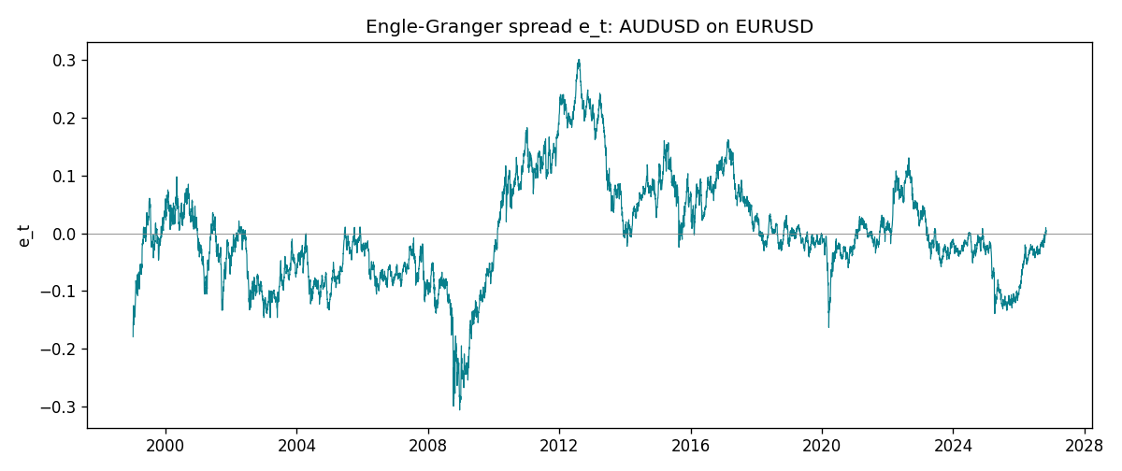
Daily log returns
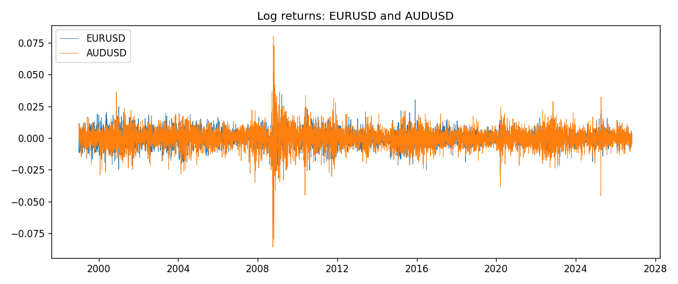

Data report
Matched rows are in the sibling Excel workbook named EURUSD-AUDUSD_Coint_D1.xlsx. Embedding all rows as a Word table is impractical; this file holds column summaries and the first and last 15 matched rows.
Column summaries
column | count | mean | std | min | 25% | 50% | 75% | max
EURUSD_open | 7201 | 1.1813268 | 0.15086382 | 0.8272 | 1.08608 | 1.16615 | 1.29393 | 1.5995
AUDUSD_open | 7201 | 0.75197127 | 0.13525779 | 0.4785 | 0.66105 | 0.73142 | 0.80912 | 1.10284
EURUSD_high | 7201 | 1.1864593 | 0.1514619 | 0.8326 | 1.0902 | 1.17128 | 1.29926 | 1.6038
AUDUSD_high | 7201 | 0.75602178 | 0.13581838 | 0.4878 | 0.6647 | 0.7349 | 0.81518 | 1.10795
EURUSD_low | 7201 | 1.1763142 | 0.15018707 | 0.8227 | 1.08202 | 1.16257 | 1.28834 | 1.5865
AUDUSD_low | 7201 | 0.74791431 | 0.13457219 | 0.4775 | 0.6577 | 0.72758 | 0.8042 | 1.0975
EURUSD_close | 7201 | 1.1813656 | 0.15083992 | 0.8267 | 1.08601 | 1.16617 | 1.29395 | 1.5997
AUDUSD_close | 7201 | 0.75202148 | 0.13524071 | 0.4786 | 0.6612 | 0.73175 | 0.80916 | 1.10169
EURUSD_tick_volume | 7201 | 103004.8 | 173409.64 | 469 | 9389 | 52708 | 99441 | 1471626
AUDUSD_tick_volume | 7201 | 77347.024 | 138135.9 | 109 | 5434 | 43320 | 71320 | 1234623
EURUSD_spread | 7201 | 19.396195 | 16.574381 | 0 | 8 | 12 | 30 | 50
AUDUSD_spread | 7201 | 30.819886 | 16.887485 | 0 | 13 | 30 | 50 | 50
EURUSD_real_volume | 7201 | 4.0238636e+10 | 1.6675367e+11 | 0 | 0 | 0 | 0 | 3.6149665e+12
AUDUSD_real_volume | 7201 | 5.2420906e+09 | 1.2538049e+11 | 0 | 0 | 0 | 0 | 3.811512e+12
EURUSD_log_price | 7201 | 0.15842157 | 0.12907932 | -0.19031341 | 0.08251043 | 0.15372487 | 0.25769956 | 0.46981611
AUDUSD_log_price | 7201 | -0.30074138 | 0.1768672 | -0.7368901 | -0.41369891 | -0.31231635 | -0.21175861 | 0.09684536
EURUSD_log_return | 7201 | -7.54e-06 | 0.00580172 | -0.03123819 | -0.00324684 | 0 | 0.00325501 | 0.03433183
AUDUSD_log_return | 7201 | 2.459e-05 | 0.00754509 | -0.08602525 | -0.00385511 | 0.00028229 | 0.00415126 | 0.0806166
spread_e | 7201 | 0 | 0.09079559 | -0.30588915 | -0.06043852 | -0.01232654 | 0.05578332 | 0.30083876
ecm_fitted | 7200 | 2.471e-05 | 0.00046833 | -0.00226907 | -0.00024253 | 2.95e-05 | 0.00029377 | 0.00402078
First 15 matched rows (selected columns)
time | EURUSD_log_price | AUDUSD_log_price | spread_e | EURUSD_log_return | AUDUSD_log_return
1999-01-05 | 0.16194877 | -0.47561937 | -0.17902558 | -0.0048360507 | -0.00080418179
1999-01-06 | 0.1504008 | -0.46378302 | -0.15361007 | -0.011547966 | 0.011836351
1999-01-07 | 0.15802886 | -0.45491799 | -0.15371482 | 0.0076280636 | 0.0088650256
1999-01-08 | 0.14712606 | -0.45460283 | -0.14057916 | -0.010902799 | 0.00031515916
1999-01-11 | 0.14002278 | -0.44738145 | -0.12500508 | -0.007103287 | 0.0072213815
1999-01-12 | 0.14453315 | -0.4522423 | -0.13516964 | 0.0045103728 | -0.0048608485
1999-01-13 | 0.1553785 | -0.46013251 | -0.1558128 | 0.010845346 | -0.0078902098
1999-01-14 | 0.1553785 | -0.46282943 | -0.15850971 | 0 | -0.002696916
1999-01-15 | 0.14522525 | -0.45570632 | -0.1394475 | -0.010153245 | 0.007123101
1999-01-18 | 0.14885095 | -0.4547604 | -0.142765 | 0.0036256946 | 0.00094592471
1999-01-19 | 0.14867859 | -0.44753788 | -0.13533981 | -0.00017235436 | 0.0072225153
1999-01-20 | 0.14548467 | -0.4462871 | -0.13033332 | -0.0031939256 | 0.0012507819
1999-01-21 | 0.14850621 | -0.44550616 | -0.13310538 | 0.0030215416 | 0.00078094498
1999-01-22 | 0.14729869 | -0.4577589 | -0.14393821 | -0.0012075213 | -0.012252745
1999-01-25 | 0.14427349 | -0.46171805 | -0.14434005 | -0.0030251979 | -0.0039591468
Last 15 matched rows (selected columns)
time | EURUSD_log_price | AUDUSD_log_price | spread_e | EURUSD_log_return | AUDUSD_log_return
2026-10-13 | 0.11301614 | -0.35923536 | -0.0051021054 | 0.0037402957 | 0.0035007712
2026-10-14 | 0.10925791 | -0.36075468 | -0.0022021609 | -0.0037582255 | -0.0015193215
2026-10-15 | 0.11486322 | -0.36829939 | -0.016338105 | 0.0056053107 | -0.0075447063
2026-10-16 | 0.11663571 | -0.36490875 | -0.01503172 | 0.0017724895 | 0.0033906408
2026-10-19 | 0.11409625 | -0.35982275 | -0.0069595876 | -0.0025394633 | 0.0050859986
2026-10-20 | 0.11648442 | -0.35636071 | -0.0063057708 | 0.0023881672 | 0.0034620426
2026-10-21 | 0.11616395 | -0.35275407 | -0.0023222977 | -0.00032046717 | 0.0036066384
2026-10-22 | 0.11456899 | -0.35402133 | -0.0017140527 | -0.0015949606 | -0.0012672558
2026-10-23 | 0.11323047 | -0.35164476 | 0.0022364686 | -0.001338521 | 0.0023765656
2026-10-26 | 0.11095981 | -0.35484804 | 0.0017032309 | -0.0022706559 | -0.0032032829
2026-10-27 | 0.10680747 | -0.35318105 | 0.0082529226 | -0.004152342 | 0.0016669876
2026-10-28 | 0.10903376 | -0.3490895 | 0.0097265978 | 0.0022262927 | 0.0040915541
2026-10-29 | 0.1112909 | -0.35318105 | 0.0029808975 | 0.0022571351 | -0.0040915541
2026-10-30 | 0.11014505 | -0.35217082 | 0.0053385242 | -0.0011458446 | 0.0010102376
2026-11-02 | 0.11226562 | -0.35708932 | -0.0020735335 | 0.002120569 | -0.0049184984

